Campus Guest Wireless

A quick overview of how to access the campus Guest Wireless Network
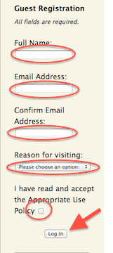
- Activate your wireless internet device, and when selecting a wireless network, choose UWNet-vilas.
- After you connect to the UWNet-vilas network, open your web browser or direct it to a new web page. You'll see an authentication page (see right). Scroll down to the Guest section.
- You'll be asked to provide the following:
  - Name
  - Email address
  - Reason for connecting (included among these is ‘Conference Attendee’)
  - You must also check the box stating you accept the campus network use policies.
- When these are filled out, submit the form, and you will be connected to internet for the rest of your stay. UWNet is also available in most other locations on campus, including the Unions and Libraries.

